(Term Project – Data Science)
AI vs Human Text Detection



By
Jawwad Ahmad
F25NDOCS3W04013
Session: Fall 2025 – 2027

Supervisor
Sir. Abdul Rehman

Master of Science in Computer Science

The Islamia University of Bahawalpur
Bahawalnagar Campus

Table of Contents
1. Introduction 1
Background: 1
Problem Statement: 1
Motivation of the Study: 1
Objectives of the Project: 1
2. Dataset Description 2
Dataset Source 2
Dataset Summary 2
Dataset Features Explanation 2
3. Methodology & Implementation 3
3.1 Dataset Loading & Preparation 4
3.1.1 Import Libraries 4
3.1.2 Dataset Uploaded 4
3.1.3 Dataset Basic Exploration 4
3.2 Exploratory Data Analysis (EDA) 6
3.2.1 Content type distribution by Label 7
3.2.2 Target Variable Distribution 8
3.2.3 Univariate Analysis 9
3.2.4 Bivariate Analysis (Feature vs Target) 10
3.2.5 Multivariate Analysis (Feature Relationships) 11
3.3 Data Cleaning & Preprocessing 12
3.3.1 Check Missing Values 12
3.3.2 Handling Missing Values 13
3.3.3 Checking Duplicate Values 14
3.3.4 Remove Unnecessary Columns 14
3.3.5 Encode Categorical Features (using Onehot Encoding) 15
3.4 Feature Engineering 16
3.4.1 Separate Features and Target Variables 16
3.4.2 Train Test Split 16
3.4.3 Feature Scaling (using Standard Scaler) 16
3.5 Model Building 18
3.6 Model Evaluation 19
3.6.1 Generate Predictions & Metrics 19
3.7 Model Evaluation 20
3.7.1 Generate Predictions & Metrics 20
3.7.2 Display Confusion Matrix (for best Accuracy Model) 21
4. Conclusion 22
4.1 Conclusion 22
4.2 What I Learned? 22

Chapter 1

Introduction

Introduction

Background:
Advances in natural language generation have enabled artificial intelligence models to produce text that closely resembles human writing in terms of structure, grammar, and readability. This progress has significantly reduced the gap between AI-generated and human-written content, posing new challenges for automated text classification.

Problem Statement:
This project addresses a supervised binary classification problem aimed at distinguishing AI-generated text from human-written text using handcrafted linguistic and readability-based features. The primary challenge arises from the substantial overlap in feature distributions between the two classes.

Motivation of the Study:
The motivation for this study lies in the growing demand for reliable AI-generated text detection in educational, publishing, and digital content moderation systems. Understanding the limitations of traditional machine learning approaches in this context is essential for developing more robust detection methods.

Objectives of the Project:
The objective of this project is to implement a complete data science workflow, including exploratory data analysis, preprocessing, model training, and evaluation to assess the effectiveness of classical machine learning models for AI vs Human text classification.

Chapter 2

Dataset Description

Dataset Description

Dataset Source
https://www.kaggle.com/datasets/pratyushpuri/ai-vs-human-content-detection-1000-record-in-2025/data

Dataset Summary
Total Records (Rows) | 1367 text_content
Total Features (Columns) | 17 columns
Target Variable | label (1 = AI-generated, 0 = Human-written)
Dataset Year: | 2025 specifications

Dataset Features Explanation
Column Name | Description
text_content | The actual textual content of the document used for analysis and feature extraction.
content_type | Category of the text such as essay, academic article, blog, or news content.
word_count | Total number of words present in the text.
character_count | Total number of characters in the text including spaces.
sentence_count | Total number of sentences in the text.
lexical_diversity | Ratio of unique words to total words, indicating vocabulary richness.
avg_sentence_length | Average number of words per sentence in the text.
avg_word_length | Average number of characters per word.
punctuation_ratio | Proportion of punctuation marks relative to total characters.
flesch_reading_ease | Readability score indicating how easy the text is to read (higher = easier).
gunning_fog_index | Measure of text complexity and years of education needed to understand it.
grammar_errors | Number of grammatical mistakes detected in the text.
passive_voice_ratio | Percentage of sentences written in passive voice.
predictability_score | Measure of how predictable or structured the text is.
burstiness | Degree of variation in sentence length throughout the text.
sentiment_score | Numerical value representing the emotional tone of the text.
label | Target variable indicating whether the text is AI-generated or Human-written.

Chapter 3

Methodology & Implementation
(Data Science Workflow)

“This chapter describes the methodology and implementation steps followed to conduct experiments for AI vs Human text classification using machine learning techniques.”

Methodology & Implementation
This study adopts a structured data science methodology to classify text as AI-generated or human-written using supervised machine learning techniques. The workflow begins with dataset loading and initial inspection, followed by exploratory data analysis to examine class distribution, feature behavior, and relationships among variables. Based on these insights, preprocessing steps such as handling missing values and feature scaling are applied to prepare the data for modeling.
The processed dataset is then divided into training and testing sets to enable fair evaluation. Multiple machine learning models, including probabilistic, distance-based, and ensemble approaches, are trained and evaluated using standard performance metrics such as accuracy, precision, recall, and F1-score. All experiments are conducted in the Google Colab environment using Python-based data science libraries, ensuring consistency and reproducibility.

Google Colab Link:
https://colab.research.google.com/drive/1IUs5znPTF9FJXhYpcvXywyL4xqjN95fn?usp=sharing

Dataset Loading & Preparation
Following steps are performed in this part:
- Import Necessary Libraries
- Dataset uploaded in csv format
- Basic Exploration

Import Libraries
import numpy as np
import pandas as pd
import matplotlib.pyplot as plt
import seaborn as sns

Dataset Uploaded
df = pd.read_csv(r'/content/ai_human_content_detection_dataset.csv')

Dataset Basic Exploration
- df.head()
- df.shape
(1367, 17)
- df.info()
<class 'pandas.core.frame.DataFrame'>
RangeIndex: 1367 entries, 0 to 1366
Data columns (total 17 columns):
# Column Non-Null Count Dtype
--- ------ -------------- -----
0 text_content 1367 non-null object
1 content_type 1367 non-null object
2 word_count 1367 non-null int64
3 character_count 1367 non-null int64
4 sentence_count 1367 non-null int64
5 lexical_diversity 1367 non-null float64
6 avg_sentence_length 1367 non-null float64
7 avg_word_length 1367 non-null float64
8 punctuation_ratio 1367 non-null float64
9 flesch_reading_ease 1288 non-null float64
10 gunning_fog_index 1332 non-null float64
11 grammar_errors 1367 non-null int64
12 passive_voice_ratio 1336 non-null float64
13 predictability_score 1367 non-null float64
14 burstiness 1367 non-null float64
15 sentiment_score 1313 non-null float64
16 label 1367 non-null int64
dtypes: float64(10), int64(5), object(2)
memory usage: 181.7+ KB

- df.describe().T
 | count | mean | std | min | 25% | 50% | 75% | max
word_count | 1367.0 | 140.190929 | 97.410218 | 3.0000 | 61.500000 | 131.00000 | 193.00000 | 443.0000
character_count | 1367.0 | 940.329188 | 654.335255 | 14.0000 | 410.500000 | 882.00000 | 1294.50000 | 2966.0000
sentence_count | 1367.0 | 25.610095 | 17.867480 | 1.0000 | 11.000000 | 24.00000 | 35.00000 | 83.0000
lexical_diversity | 1367.0 | 0.967646 | 0.026254 | 0.8750 | 0.951550 | 0.96920 | 0.98910 | 1.0000
avg_sentence_length | 1367.0 | 5.486423 | 0.447202 | 3.0000 | 5.270000 | 5.48000 | 5.70000 | 8.0000
avg_word_length | 1367.0 | 5.717783 | 0.279636 | 4.0000 | 5.590000 | 5.71000 | 5.83000 | 8.3300
punctuation_ratio | 1367.0 | 0.027440 | 0.002801 | 0.0194 | 0.026100 | 0.02720 | 0.02840 | 0.0714
flesch_reading_ease | 1288.0 | 52.183377 | 10.466570 | -50.0100 | 47.712500 | 52.19000 | 57.32250 | 98.8700
gunning_fog_index | 1332.0 | 7.556877 | 1.866676 | 1.2000 | 6.620000 | 7.51500 | 8.39000 | 27.8700
grammar_errors | 1367.0 | 1.537674 | 1.912012 | 0.0000 | 0.000000 | 1.00000 | 3.00000 | 10.0000
passive_voice_ratio | 1336.0 | 0.150198 | 0.056738 | 0.0500 | 0.099675 | 0.15135 | 0.20015 | 0.2500
predictability_score | 1367.0 | 62.779049 | 28.223550 | 20.0300 | 39.015000 | 56.82000 | 86.64500 | 119.9300
burstiness | 1367.0 | 0.427041 | 0.199249 | 0.1011 | 0.250000 | 0.40850 | 0.59430 | 0.7995
sentiment_score | 1313.0 | -0.007997 | 0.588354 | -0.9993 | -0.525800 | -0.00620 | 0.50280 | 0.9959
label | 1367.0 | 0.499634 | 0.500183 | 0.0000 | 0.000000 | 0.00000 | 1.00000 | 1.0000

Description:
In this step, essential Python libraries such as NumPy, Pandas, Matplotlib, and Seaborn are imported to support data processing and visualization. The dataset is then uploaded into the Google Colab environment using the Pandas read_csv function. Basic exploration is performed using functions like head(), shape, and info() to understand the dataset structure, size, data types, and presence of missing values. Summary statistics are obtained using describe() to gain an initial understanding of numerical feature distributions.

Exploratory Data Analysis (EDA)
Exploratory Data Analysis (EDA) is performed to understand data distribution, class balance, and relationships between features and the target variable. Visualizations are used to identify patterns that may influence model performance. Following analysis are performed under this portion:

Analysis | Description
- Content type distribution by Label | This analysis examines how different content types (e.g., blogs, essays, academic content) are distributed across the target classes (AI-generated vs human-written).
- Target Variable Distribution | This analysis visualizes the distribution of the target variable (labels) in the dataset.
- Univariate Analysis | Univariate analysis focuses on examining the distribution of individual features independently.
- Bivariate Analysis (Feature vs Target) | Bivariate analysis explores the relationship between each feature and the target variable.
- Multivariate Analysis (Feature Relationships) | Multivariate analysis examines relationships among multiple features simultaneously, often using correlation analysis.

Content type distribution by Label

Code
# Check if 'label' is numeric and convert for visualization
df['label'] = df['label'].map({0: 'Human', 1: 'AI'})
# Plot barplot of content_type with hue by label
plt.figure(figsize=(10, 6))
sns.countplot(data=df, x='content_type', hue='label', palette='Set2')
plt.title("Content Type Distribution by Label")
plt.xlabel("Content Type")
plt.ylabel("Count")
plt.xticks(rotation=50)
plt.tight_layout()
plt.show()

Diagram
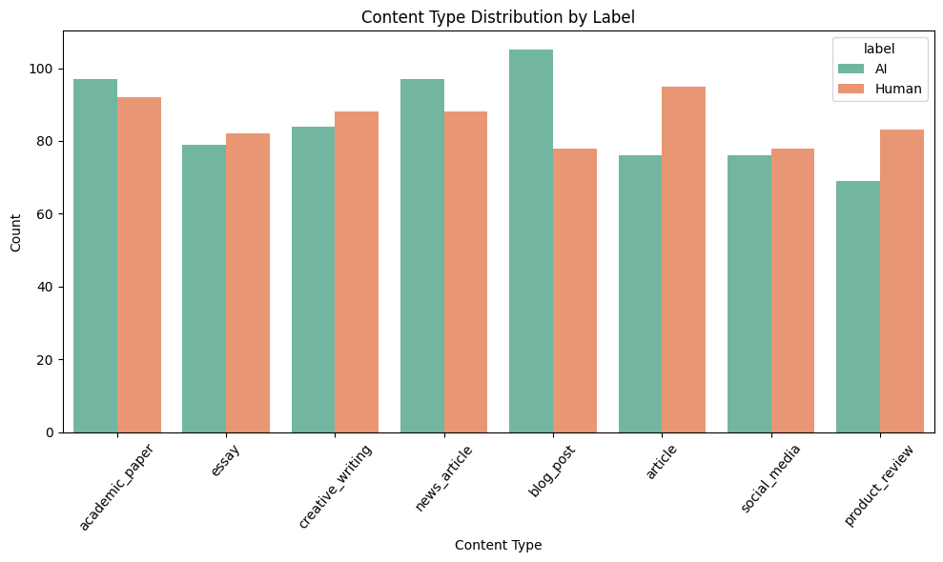

Target Variable Distribution

Code
# Count the number of samples for each class
label_counts = df['label'].value_counts()
# Display counts
print(label_counts)
plt.figure()
label_counts.plot(kind='bar')
plt.xlabel('Class Label')
plt.ylabel('Number of Samples')
plt.title('Target Variable Distribution (0=Human, 1=AI)')
plt.show()

Diagram
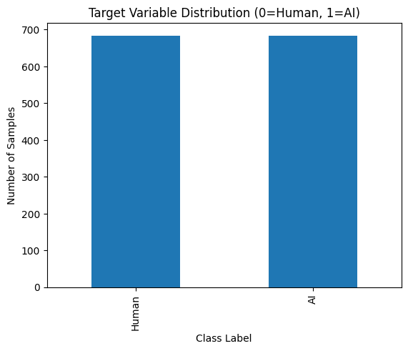

Description
The target variable distribution shows that the dataset is well balanced between human-written (0) and AI-generated (1) content, with a nearly equal number of samples in both classes. This balance is important as it prevents model bias toward a dominant class during training. A balanced target distribution allows accuracy and other evaluation metrics to be reliable and meaningful. Overall, the dataset is suitable for fair and effective binary classification.

Univariate Analysis

Code
plt.figure(figsize=(8, 8))
def plotting(var,num):
plt.subplot(3,2,num)
sns.histplot(df[var], bins=30, kde = True)
plotting("word_count",1)
plotting("sentence_count",2)
plotting("grammar_errors",3)
plotting("lexical_diversity",4)
plotting("flesch_reading_ease",5)
plotting("gunning_fog_index", 6)
plt.tight_layout()

Diagram
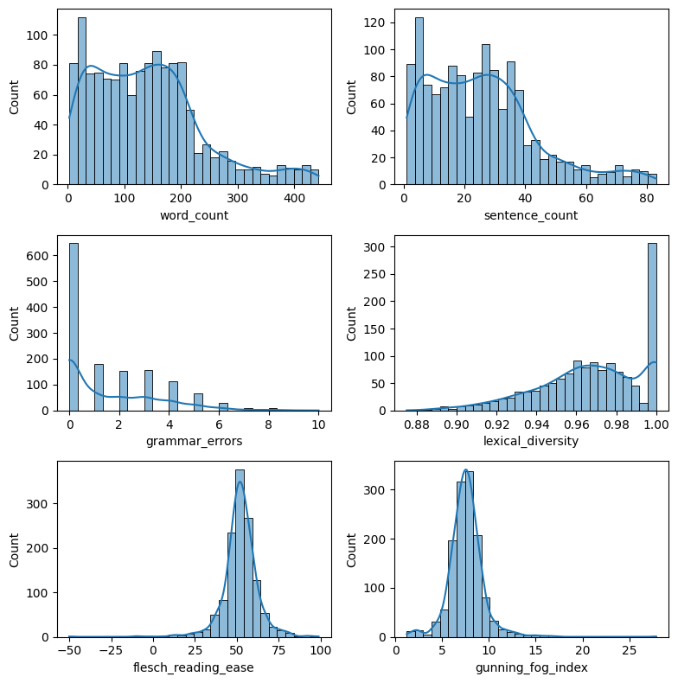

Description
- The word count and sentence count features exhibit right-skewed distributions, indicating that most text samples are relatively short, with a smaller number of longer documents.
- Grammar errors are mostly concentrated at lower values, suggesting that the majority of content is grammatically sound.
- Lexical diversity is highly concentrated toward higher values, showing limited variation in vocabulary richness across samples.
- Readability metrics such as Flesch Reading Ease and Gunning Fog Index display clear distribution patterns, reflecting differences in text complexity and readability that may help distinguish AI-generated and human-written content.

Bivariate Analysis (Feature vs Target)

Code
features_to_plot = ['word_count', 'grammar_errors', 'lexical_diversity', 'predictability_score', 'burstiness', 'sentiment_score']
fig, axes = plt.subplots(nrows=2, ncols=3, figsize=(18, 10))
axes = axes.flatten()
for i, col in enumerate(features_to_plot):
sns.boxplot(data=df, x='label', y=col, ax=axes[i])
axes[i].set_title(f"{col} by Label")
plt.tight_layout()
plt.show()

Diagram

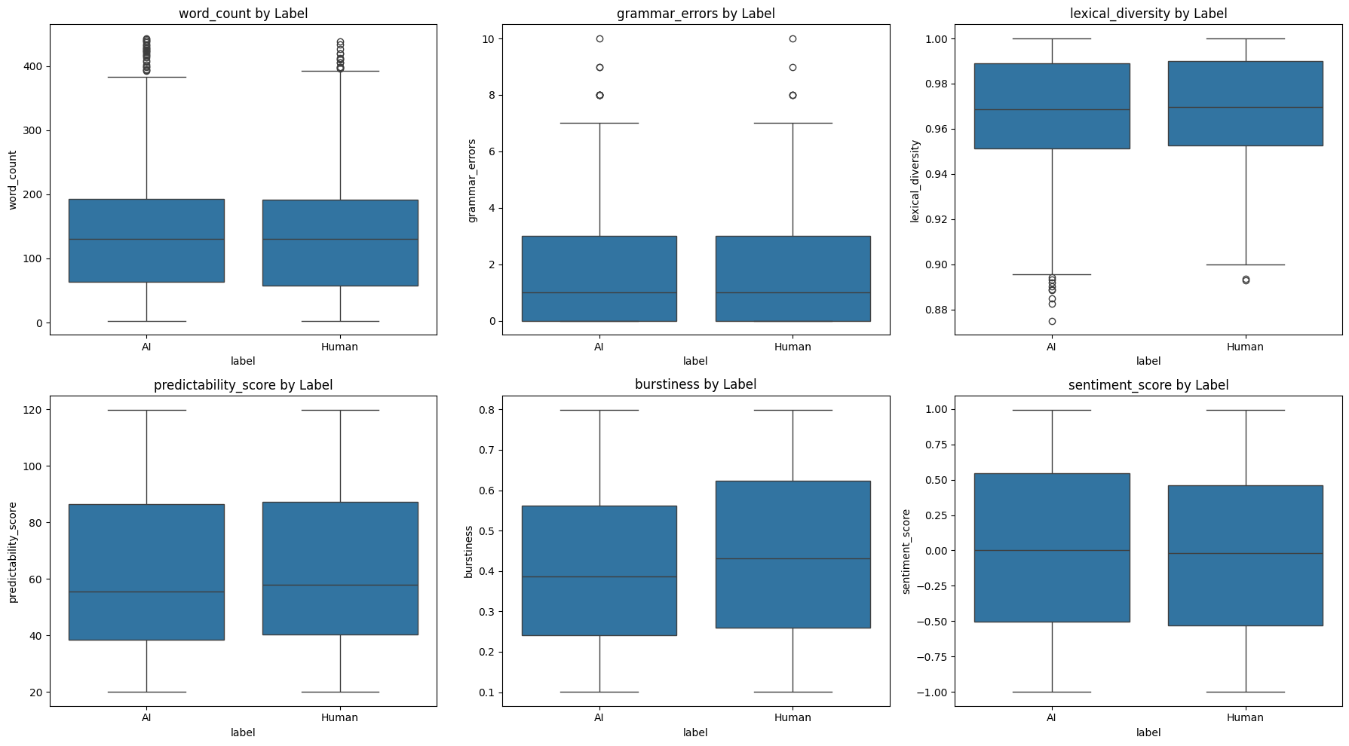

Description
- The word count distribution shows a comparable range for both AI-generated and human-written content, indicating that text length alone is not a strong distinguishing factor.
- Grammar errors are generally low for both classes, suggesting that both AI and human texts are grammatically well-formed, though slight variation exists.
- Lexical diversity values are high for both classes, with human-written content showing marginally greater variability, reflecting more diverse vocabulary usage.
- Predictability score and burstiness show noticeable differences between AI and human text, indicating their potential usefulness in distinguishing writing patterns.
- Sentiment scores appear broadly distributed across both classes, suggesting that sentiment alone may have limited discriminative power.

Multivariate Analysis (Feature Relationships)

Code
plt.figure(figsize=(14, 10))
corr = df.corr(numeric_only=True)
sns.heatmap(corr, annot=True, cmap='coolwarm', fmt=".2f", square=True)
plt.title("Correlation Matrix")
plt.show()

Diagram

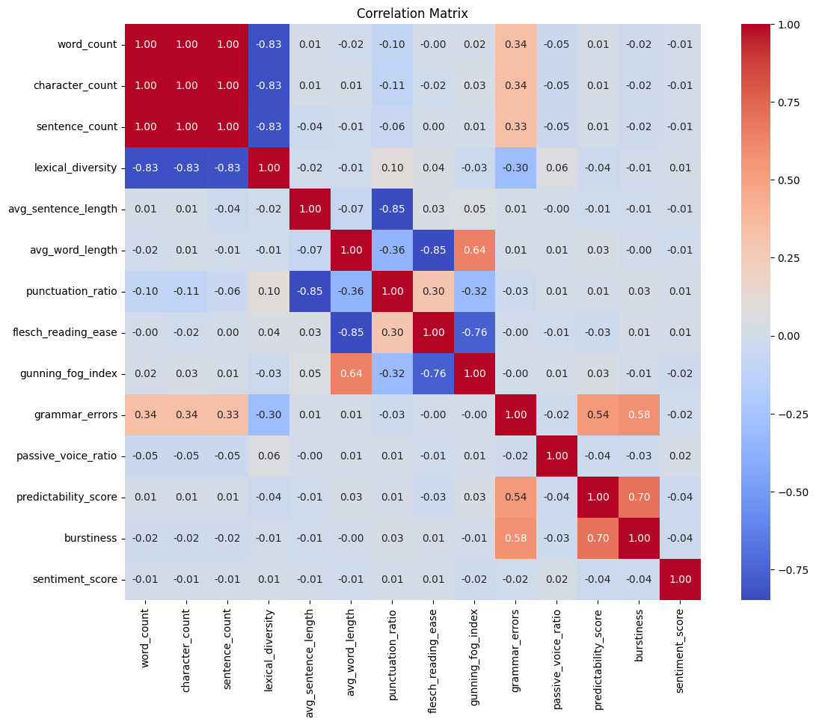

Description
- It shows the correlation matrix of extracted features. Word count, character count, and sentence count are highly correlated, indicating redundancy among length-based attributes. Lexical diversity is strongly negatively correlated with text length, reflecting reduced vocabulary variation in longer texts.
- Readability measures exhibit strong interdependence, with Flesch Reading Ease inversely correlated with the Gunning Fog Index. Average word length is positively associated with text complexity. Stylistic features, including grammar errors, predictability score, and burstiness, show moderate positive correlations, suggesting their relevance for AI–human text discrimination. Sentiment score and passive voice ratio display weak correlations, indicating limited discriminative contribution.

Data Cleaning & Preprocessing

Check Missing Values
df.isnull().sum()
text_content 0
content_type 0
word_count 0
character_count 0
sentence_count 0
lexical_diversity 0
avg_sentence_length 0
avg_word_length 0
punctuation_ratio 0
flesch_reading_ease 79
gunning_fog_index 35
grammar_errors 0
passive_voice_ratio 31
predictability_score 0
burstiness 0
sentiment_score 54
label 0
dtype: int64
plt.figure(figsize=(12, 8))
sns.heatmap(df.isnull(), cbar=False, cmap='Reds')
plt.title("Missing Values Heatmap")
plt.show()

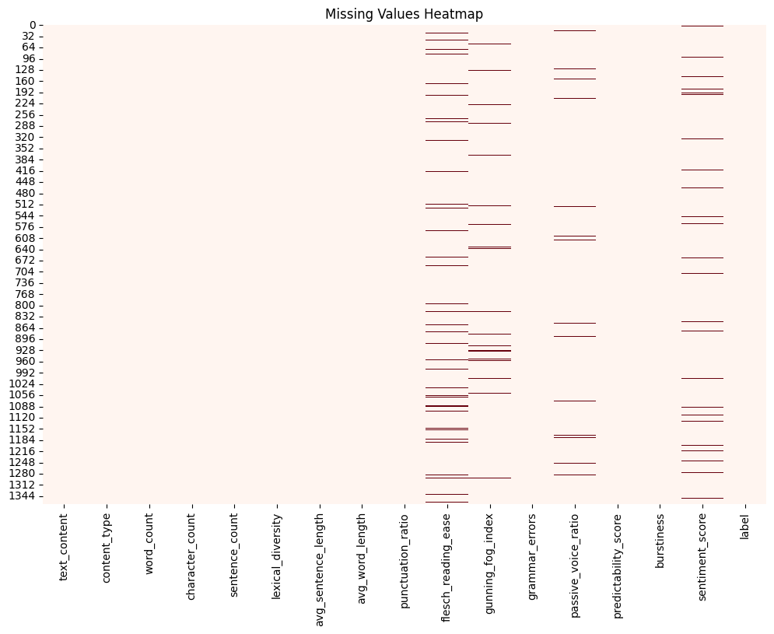

Handling Missing Values

Code
# List of columns with missing values
missing_cols = [
"flesch_reading_ease",
"gunning_fog_index",
"passive_voice_ratio",
"sentiment_score"
]
# Fill missing values using median
for col in missing_cols:
median_value = df[col].median()
df[col] = df[col].fillna(median_value)
# Verify that missing values are handled
df.isnull().sum()

Output

text_content 0
content_type 0
word_count 0
character_count 0
sentence_count 0
lexical_diversity 0
avg_sentence_length 0
avg_word_length 0
punctuation_ratio 0
flesch_reading_ease 0
gunning_fog_index 0
grammar_errors 0
passive_voice_ratio 0
predictability_score 0
burstiness 0
sentiment_score 0
label 0
dtype: int64

Description
Missing values were observed in readability and linguistic features such as Flesch Reading Ease, Gunning Fog Index, Passive Voice Ratio, and Sentiment Score. Since these are continuous numerical variables and the proportion of missing values was small, median imputation was applied to preserve dataset size and reduce the impact of outliers.

Checking Duplicate Values

Code
# Count duplicate rows
duplicate_count = df.duplicated().sum()
duplicate_count

Output
np.int64(0)

Description
No duplicate records were found in the dataset, indicating that each instance represents a unique content sample.

Remove Unnecessary Columns

Code
df.columns

Output
Index(['text_content', 'content_type', 'word_count', 'character_count',
'sentence_count', 'lexical_diversity', 'avg_sentence_length',
'avg_word_length', 'punctuation_ratio', 'flesch_reading_ease',
'gunning_fog_index', 'grammar_errors', 'passive_voice_ratio',
'predictability_score', 'burstiness', 'sentiment_score', 'label'],
dtype='object')
# Drop raw text column (not used in numerical ML models)
df.drop(columns=["text_content"], inplace=True)
df.columns

Code

Output
Index(['content_type', 'word_count', 'character_count', 'sentence_count',
'lexical_diversity', 'avg_sentence_length', 'avg_word_length',
'punctuation_ratio', 'flesch_reading_ease', 'gunning_fog_index',
'grammar_errors', 'passive_voice_ratio', 'predictability_score',
'burstiness', 'sentiment_score', 'label'],
dtype='object')

Description
The raw text feature (text_content) was removed since the modeling pipeline relies on numerical and categorical features only, and no text vectorization techniques were applied. All remaining features represent engineered linguistic, readability, and stylistic metrics relevant for AI–human content classification.

Encode Categorical Features (using Onehot Encoding)

Code
# Converting lable feature to numeric
df['label'] = df['label'].map({'Human': 0, 'AI': 1})
# Identify categorical columns
df.select_dtypes(include=["object"]).columns
Index(['content_type'], dtype='object')
# One-Hot Encode the categorical feature
df = pd.get_dummies(df, columns=["content_type"], drop_first=True)
df.head()
{"type":"dataframe","variable_name":"df"}
# Convert boolean columns to integers
bool_cols = df.select_dtypes(include="bool").columns
df[bool_cols] = df[bool_cols].astype(int)

Description
The categorical feature content_type was converted into numerical form using one-hot encoding. This approach prevents the introduction of artificial ordinal relationships and ensures compatibility with machine learning algorithms such as Logistic Regression, SVM, and Random Forest.

Feature Engineering

Separate Features and Target Variables

Code
# Features (all columns except target)
X = df.drop(columns=["label"])
# Target variable
y = df["label"]
# Verify shapes
X.shape, y.shape

Output

((1367, 21), (1367,))

Train Test Split

Code
from sklearn.model_selection import train_test_split
# Split the data
X_train, X_test, y_train, y_test = train_test_split(
X,
y,
test_size=0.2,
random_state=42,
stratify=y
)
# Verify shapes
X_train.shape, X_test.shape, y_train.shape, y_test.shape

Output
((1093, 21), (274, 21), (1093,), (274,))

Feature Scaling (using Standard Scaler)

Code
# Identify one-hot encoded columns
binary_cols = [col for col in X_train.columns if col.startswith("content_type_")]
# Identify numerical columns
numerical_cols = [col for col in X_train.columns if col not in binary_cols]

Description
from sklearn.preprocessing import StandardScaler
scaler = StandardScaler()
# Scale numerical features
X_train_scaled_num = scaler.fit_transform(X_train[numerical_cols])
X_test_scaled_num = scaler.transform(X_test[numerical_cols])
# Convert back to DataFrame
X_train_scaled_num = pd.DataFrame(X_train_scaled_num, columns=numerical_cols)
X_test_scaled_num = pd.DataFrame(X_test_scaled_num, columns=numerical_cols)
# Add binary features back without scaling
X_train_final = pd.concat([X_train_scaled_num, X_train[binary_cols].reset_index(drop=True)], axis=1)
X_test_final = pd.concat([X_test_scaled_num, X_test[binary_cols].reset_index(drop=True)], axis=1)

Continuous numerical features were standardized using StandardScaler. One-hot encoded categorical features were excluded from scaling to preserve their binary semantics and improve model interpretability.

Model Building
Naïve Bayes, Logistic Regression, Gradient Boost, SVM, KNN, XGBoost are used.

Code
# Import models
from sklearn.naive_bayes import GaussianNB
from sklearn.linear_model import LogisticRegression
from sklearn.ensemble import RandomForestClassifier, GradientBoostingClassifier
from sklearn.svm import SVC
from sklearn.neighbors import KNeighborsClassifier
# Try importing XGBoost (optional / advanced)
try:
from xgboost import XGBClassifier
xgboost_available = True
except ImportError:
xgboost_available = False
# Dictionary of models
models = {
"Naive Bayes": GaussianNB(),
"Logistic Regression": LogisticRegression(max_iter=1000, random_state=42),
"Random Forest": RandomForestClassifier(
n_estimators=100, random_state=42, n_jobs=-1
),
"SVM": SVC(kernel="linear", random_state=42),
"KNN": KNeighborsClassifier(n_neighbors=9),
"Gradient Boosting": GradientBoostingClassifier(random_state=42)
}
# Add XGBoost if available
if xgboost_available:
models["XGBoost"] = XGBClassifier(
eval_metric="logloss",
random_state=42
)
# Train all models
trained_models = {}
for model_name, model in models.items():
model.fit(X_train_final, y_train)
trained_models[model_name] = model
print(f"{model_name} trained successfully.")

Output
Naive Bayes trained successfully.
Logistic Regression trained successfully.
Random Forest trained successfully.
SVM trained successfully.
KNN trained successfully.
Gradient Boosting trained successfully.
XGBoost trained successfully.

Model Evaluation
Following classification evaluation metrics are used:
Metric | Description
- Accuracy | Measures how many predictions the model got correct out of all predictions.
- Precision | Precision quantifies the proportion of correctly predicted positive instances among all predicted positives.
- Recall | Recall (also known as sensitivity) measures the proportion of actual positive instances that are correctly identified by the model.
- F1-Score | The F1-score is the harmonic mean of precision and recall, providing a balanced measure when class distributions are uneven.

Generate Predictions & Metrics

Code
from sklearn.metrics import accuracy_score, precision_score, recall_score, f1_score
results = []
for model_name, model in trained_models.items():
y_pred = model.predict(X_test_final)
results.append({
"Model": model_name,
"Accuracy": accuracy_score(y_test, y_pred),
"Precision": precision_score(y_test, y_pred, average='weighted'),
"Recall": recall_score(y_test, y_pred, average='weighted'),
"F1 Score": f1_score(y_test, y_pred, average='weighted')
})
results_df = pd.DataFrame(results)
results_df

Output

Model | Accuracy | Precision | Recall | F1 Score
Naive Bayes | 0.532847 | 0.532910 | 0.532847 | 0.532623
Logistic Regression | 0.503650 | 0.503653 | 0.503650 | 0.503544
Random Forest | 0.492701 | 0.492489 | 0.492701 | 0.489101
SVM | 0.474453 | 0.473776 | 0.474453 | 0.471042
KNN | 0.543796 | 0.544481 | 0.543796 | 0.542033
Gradient Boosting | 0.496350 | 0.496347 | 0.496350 | 0.496243
XGBoost | 0.503650 | 0.503678 | 0.503650 | 0.502696

Model Evaluation
Following classification evaluation metrics are used:
Metric | Description
- Accuracy | Measures how many predictions the model got correct out of all predictions.
- Precision | Precision quantifies the proportion of correctly predicted positive instances among all predicted positives.
- Recall | Recall (also known as sensitivity) measures the proportion of actual positive instances that are correctly identified by the model.
- F1-Score | The F1-score is the harmonic mean of precision and recall, providing a balanced measure when class distributions are uneven.

Generate Predictions & Metrics

Code
from sklearn.metrics import accuracy_score, precision_score, recall_score, f1_score
results = []
for model_name, model in trained_models.items():
y_pred = model.predict(X_test_final)
results.append({
"Model": model_name,
"Accuracy": accuracy_score(y_test, y_pred),
"Precision": precision_score(y_test, y_pred, average='weighted'),
"Recall": recall_score(y_test, y_pred, average='weighted'),
"F1 Score": f1_score(y_test, y_pred, average='weighted')
})
results_df = pd.DataFrame(results)
results_df

Output

Model | Accuracy | Precision | Recall | F1 Score
Naive Bayes | 0.532847 | 0.532910 | 0.532847 | 0.532623
Logistic Regression | 0.503650 | 0.503653 | 0.503650 | 0.503544
Random Forest | 0.492701 | 0.492489 | 0.492701 | 0.489101
SVM | 0.474453 | 0.473776 | 0.474453 | 0.471042
KNN | 0.543796 | 0.544481 | 0.543796 | 0.542033
Gradient Boosting | 0.496350 | 0.496347 | 0.496350 | 0.496243
XGBoost | 0.503650 | 0.503678 | 0.503650 | 0.502696

Display Confusion Matrix (for best Accuracy Model)

Code
best_model_name = results_df.sort_values(by="Accuracy", ascending=False).iloc[0]["Model"]
best_model = trained_models[best_model_name]
print("Best Model:", best_model_name)
from sklearn.metrics import confusion_matrix, ConfusionMatrixDisplay
y_pred_best = best_model.predict(X_test_final)
cm = confusion_matrix(y_test, y_pred_best)
disp = ConfusionMatrixDisplay(confusion_matrix=cm)
disp.plot()

Output
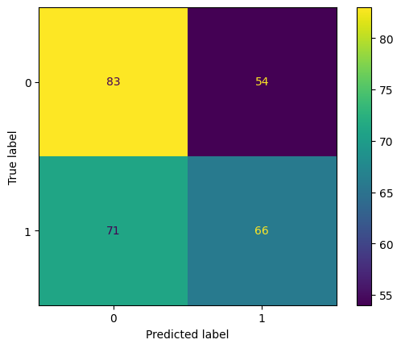
Best Model: KNN

Description

The confusion matrix illustrates the model’s ability to distinguish between AI-generated and human-written text. The model correctly identifies 83 AI-generated texts and 66 human-written texts, while 54 AI-generated samples are incorrectly classified as human-written and 71 human-written samples are misclassified as AI-generated. These misclassifications indicate overlap in writing patterns between AI and human text, highlighting the inherent challenge of accurately separating the two classes.

Chapter 4

Conclusion

4. Conclusion

4.1 Conclusion
This study investigated the problem of distinguishing AI-generated text from human-written content using a structured data science approach and supervised machine learning techniques. A complete analytical pipeline was implemented, encompassing exploratory data analysis, data preprocessing, feature-based representation, model training, and performance evaluation. Several classification models were developed and compared using standard evaluation metrics. The experimental results indicate that although the overall classification accuracy remains moderate, the selected linguistic and statistical features provide meaningful discriminatory information between AI-generated and human-authored text. Nevertheless, this work establishes a solid baseline and contributes valuable insights for further research in automated AI content detection.

4.2 What I Learned?
- Developed the ability to design and implement a complete data science workflow, from data ingestion to model evaluation.
- Strengthened skills in exploratory data analysis to extract insights and understand feature behavior.
- Gained practical experience in applying and comparing multiple machine learning classification algorithms.
- Learned to evaluate model performance using appropriate metrics and interpret moderate results in the context of real-world data complexity.
- Enhanced understanding of feature importance analysis and its role in model interpretability.
- Improved critical thinking and problem-solving skills by identifying limitations and potential areas for improvement in machine learning solutions.

